LAB Logbook

Lab 1

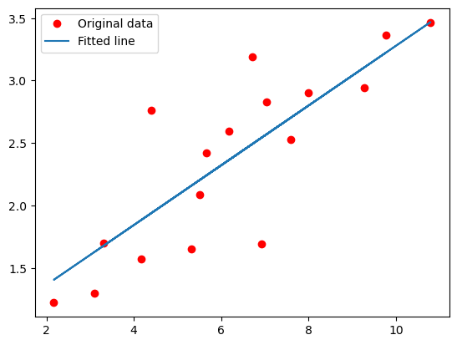

Lab 2

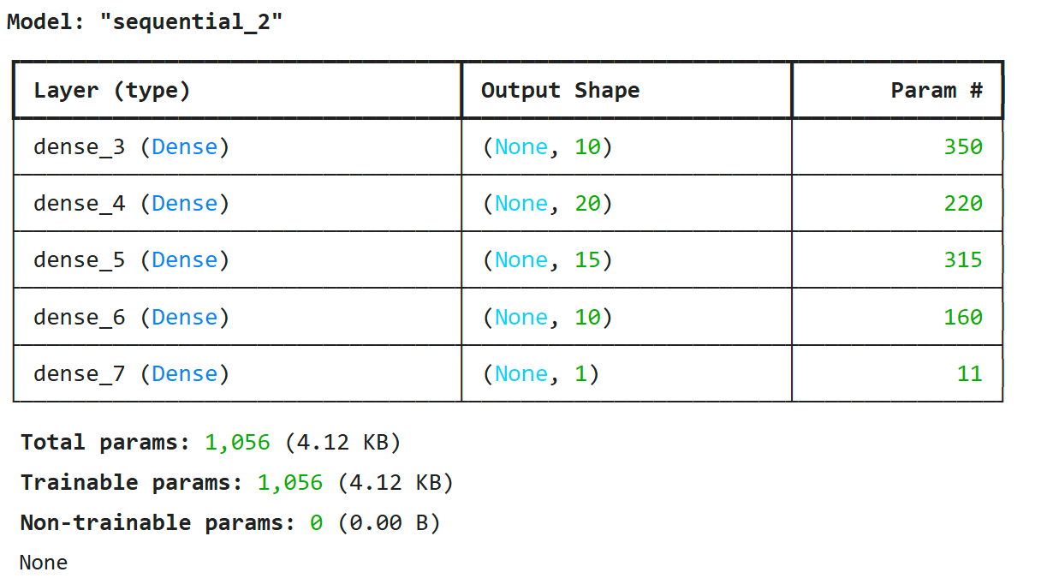

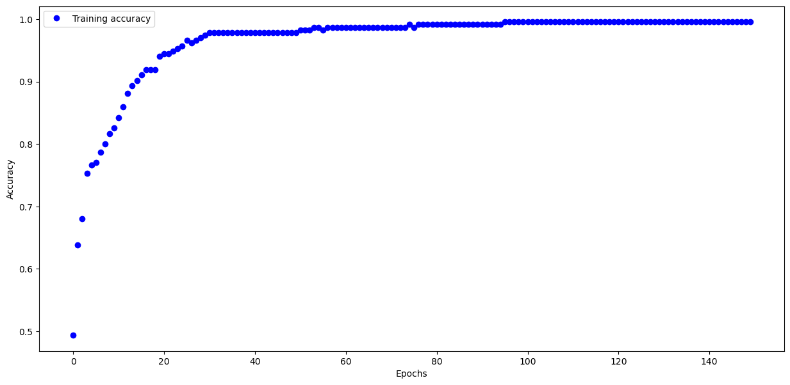

Lab 3

Test accuracy: 0.8855999708175659

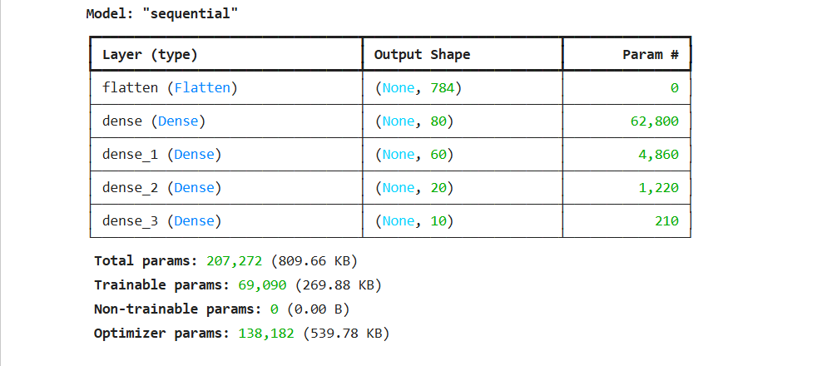

Lab 4

**Model: "sequential_2"**

┏━━━━━━━━━━━━━━━━━━━━━━━━━━━━━━━━━┳━━━━━━━━━━━━━━━━━━━━━━━━┳━━━━━━━━━━━━━━━┓

┃ **Layer (type)** ┃ **Output Shape** ┃ **Param #** ┃

┡━━━━━━━━━━━━━━━━━━━━━━━━━━━━━━━━━╇━━━━━━━━━━━━━━━━━━━━━━━━╇━━━━━━━━━━━━━━━┩

│ dense_6 (Dense) │ (None, 152) │ 3,040 │

├─────────────────────────────────┼────────────────────────┼───────────────┤

│ dense_7 (Dense) │ (None, 64) │ 9,792 │

├─────────────────────────────────┼────────────────────────┼───────────────┤

│ dense_8 (Dense) │ (None, 32) │ 2,080 │

├─────────────────────────────────┼────────────────────────┼───────────────┤

│ dense_9 (Dense) │ (None, 1) │ 33 │

└─────────────────────────────────┴────────────────────────┴───────────────┘

**Total params:** 14,945 (58.38 KB)

**Trainable params:** 14,945 (58.38 KB)

**Non-trainable params:** 0 (0.00 B)

None

**absolute prediction error = 68057.0 $**

**relative prediction error = 30.670121676430824 %**

Lab 5

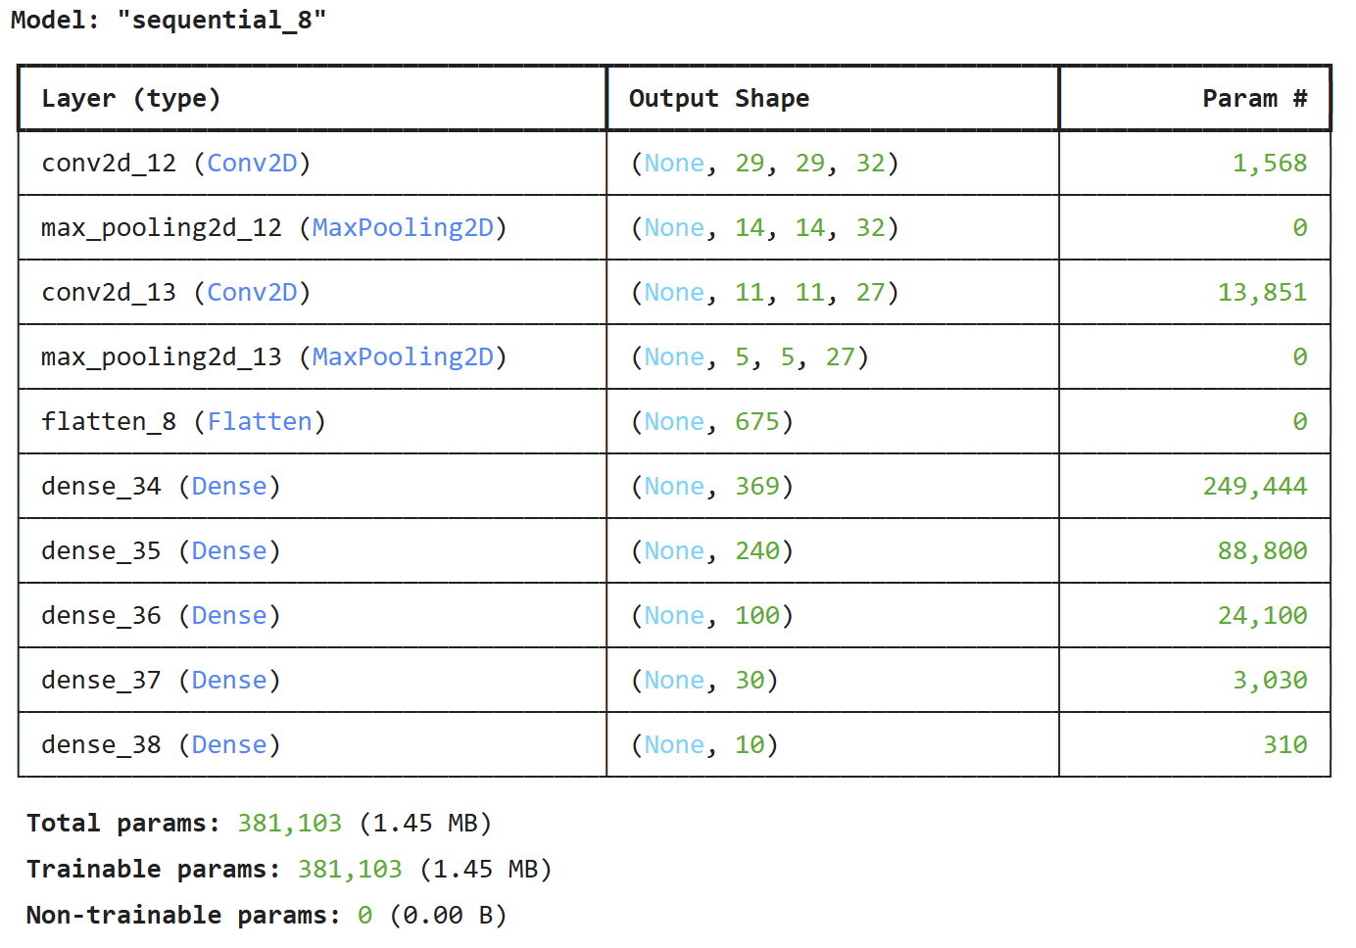

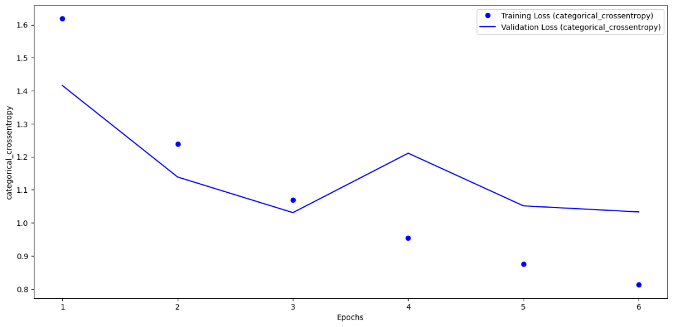

Lab 6

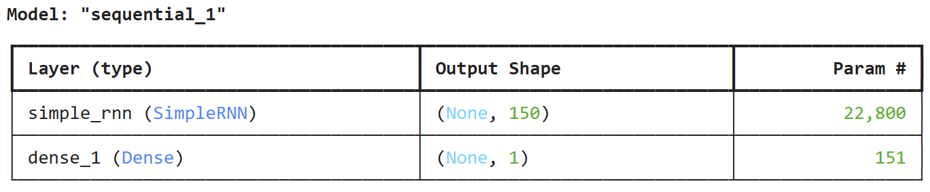

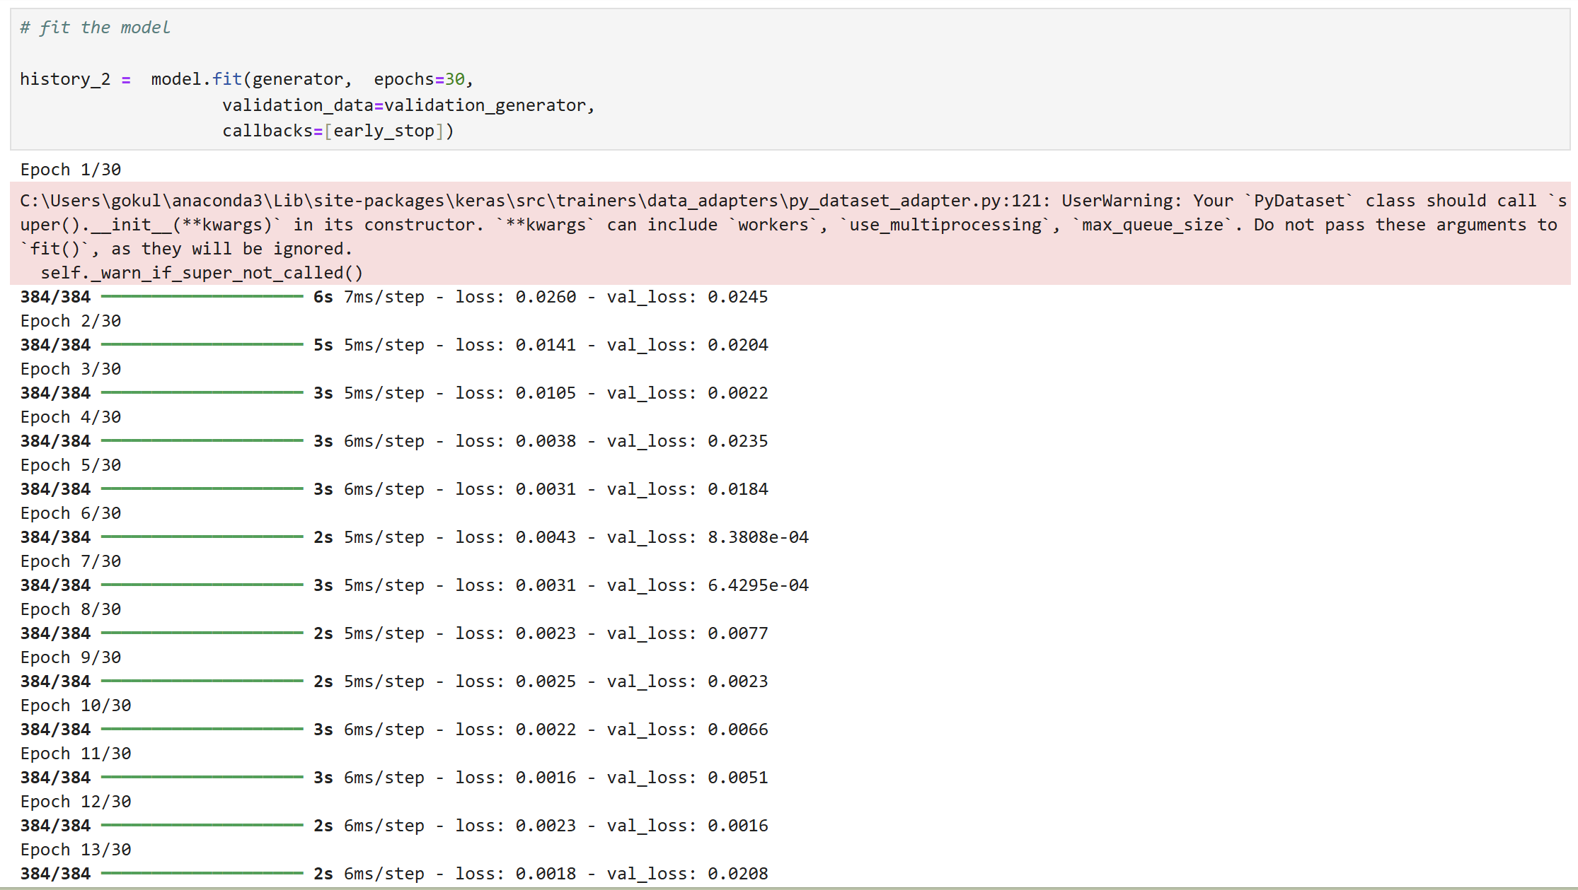

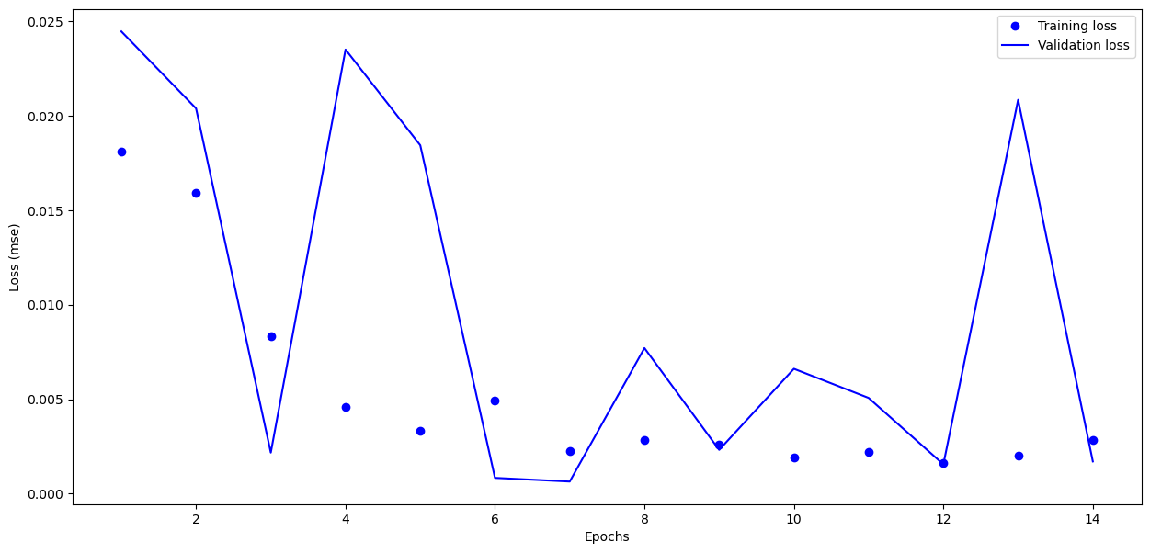

Epochs = 14

Lab 7

Graphs for Accuracy and Loss Function for VGG16 and VGG19

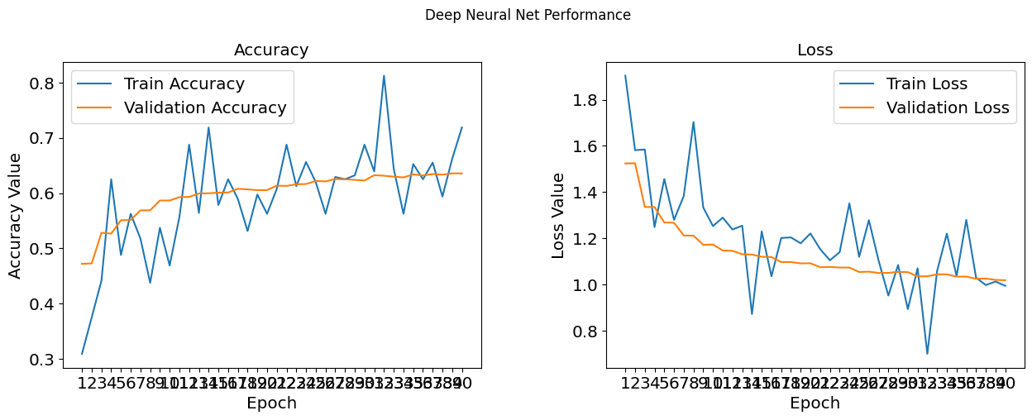

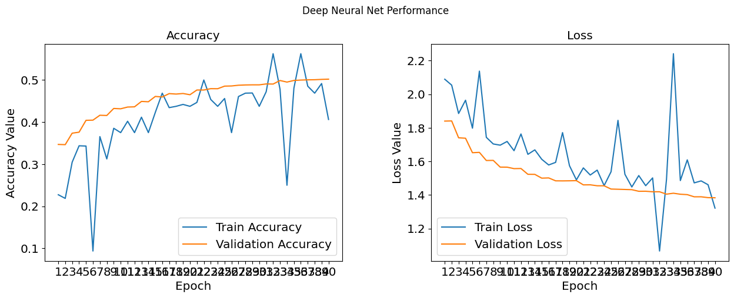

Lab 8

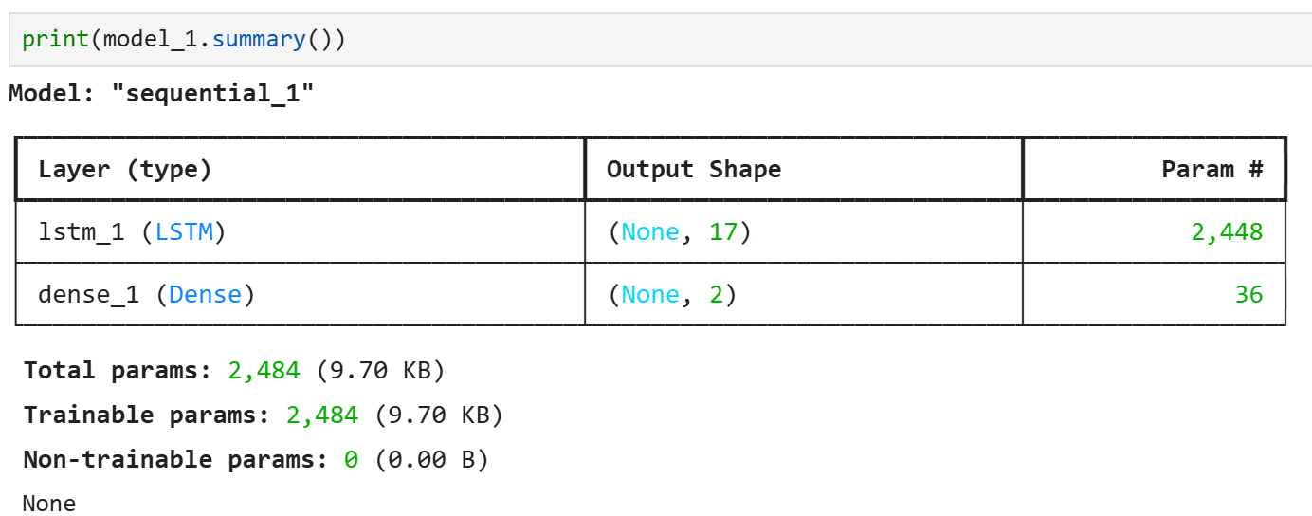

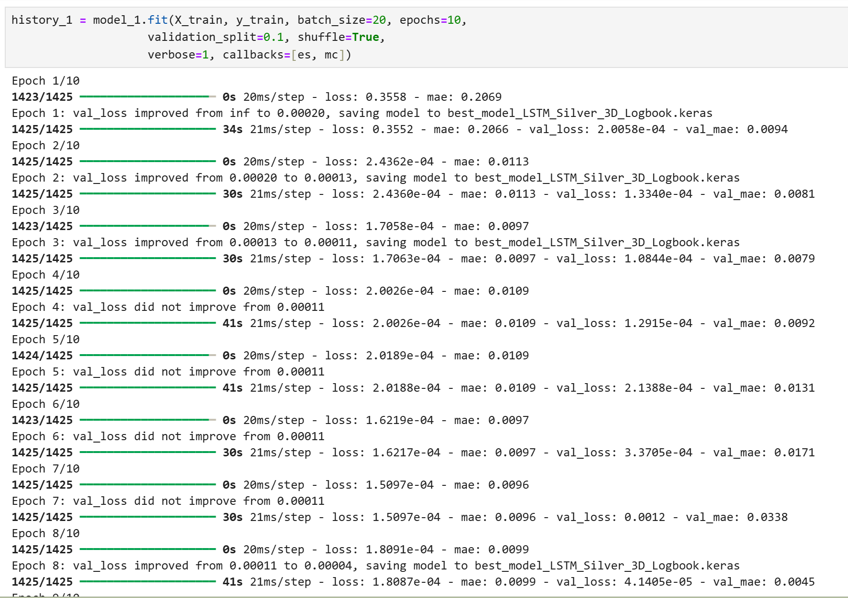

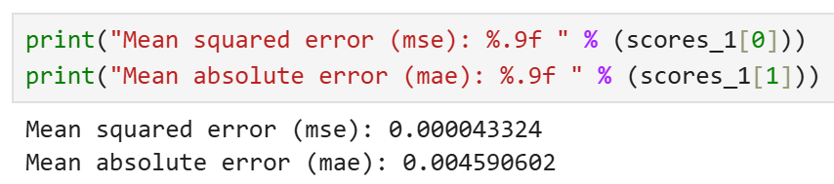

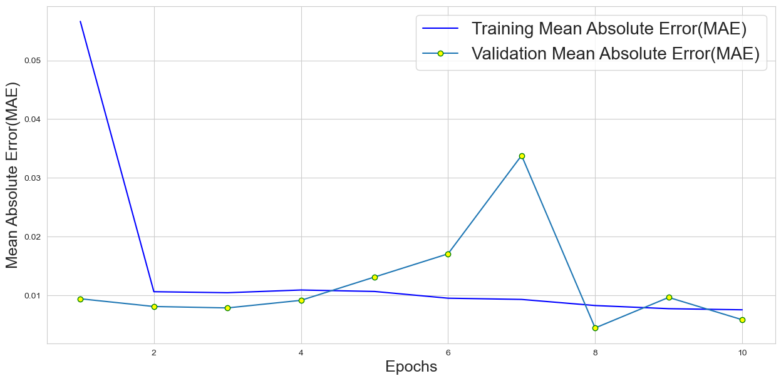

Lab 9



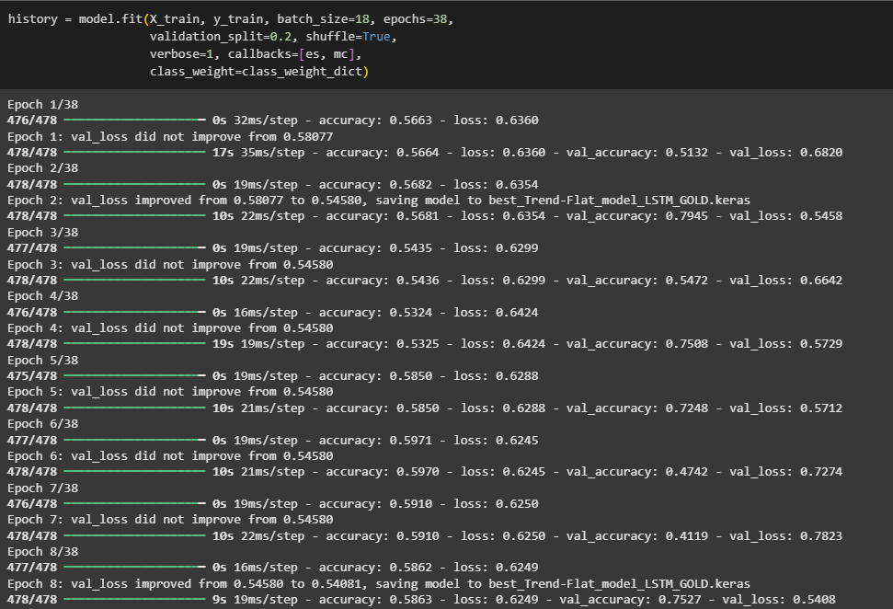

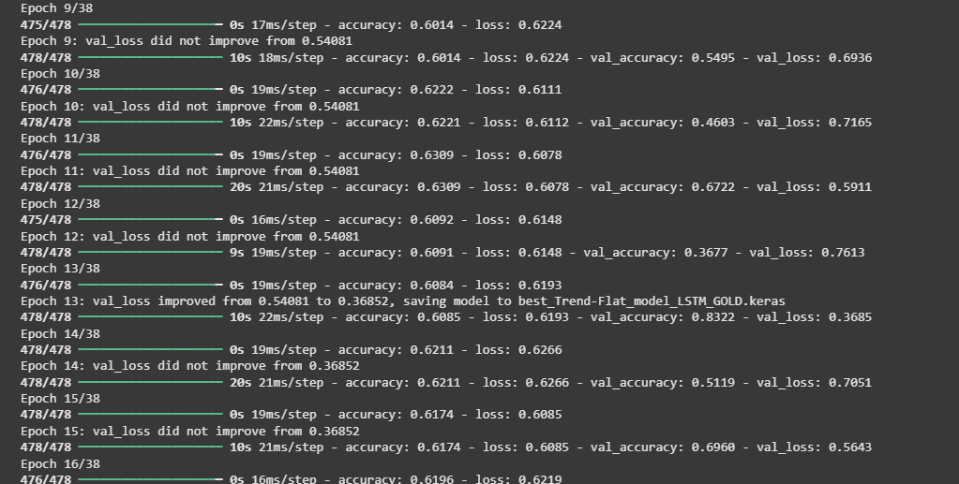



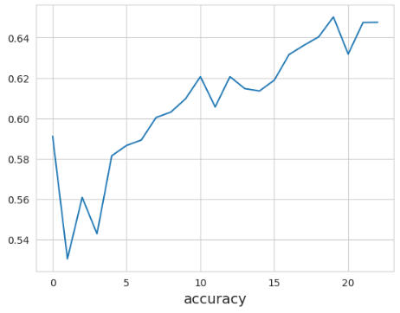

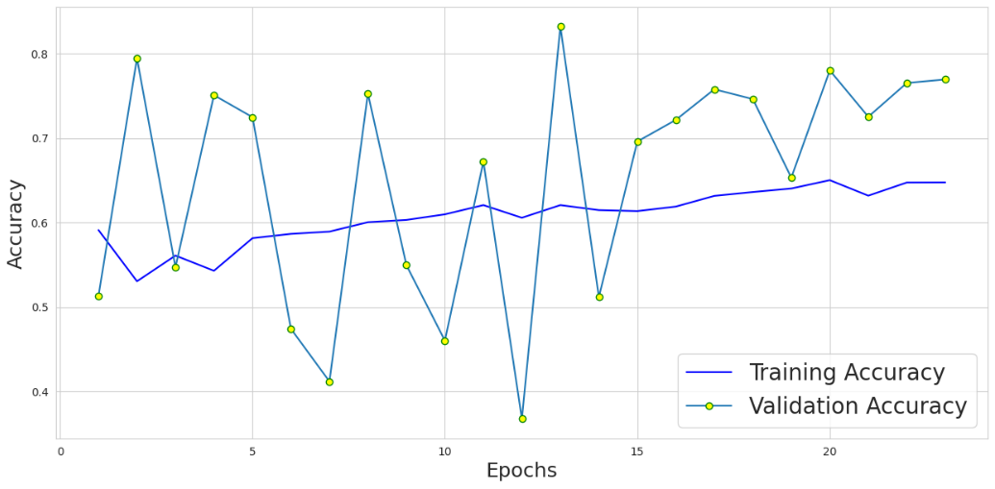

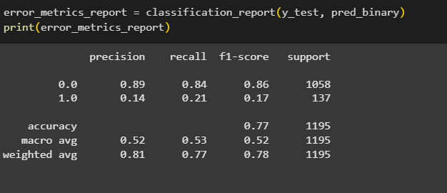

Lab 10

Task 1 – Encoder

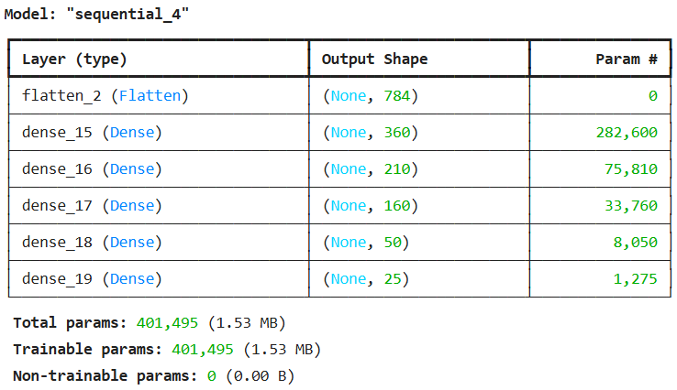

Decoder

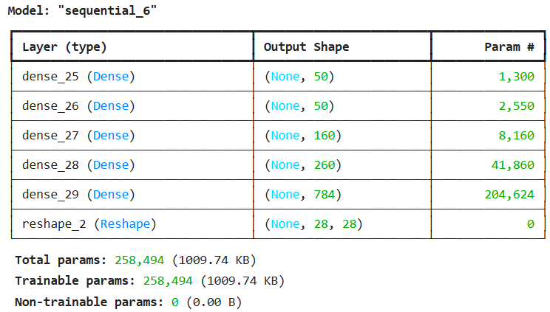

Autoencoder 1

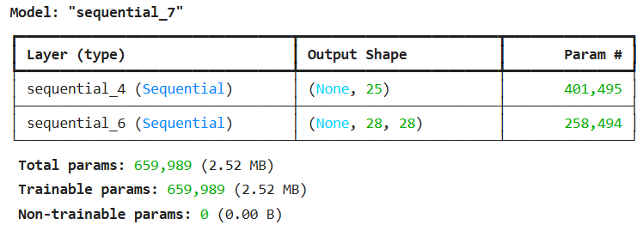

Task 2

Autoencoders 2

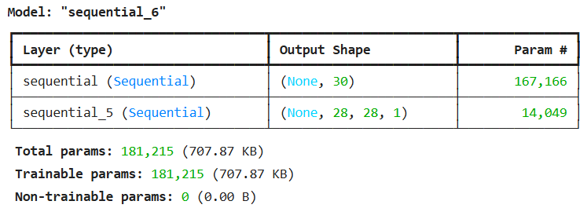

history_2 = autoencoder.fit(x=x_train, y=x_train, epochs=48,batch_size=128,shuffle=True, verbose=1,validation_data=(x_test, x_test))

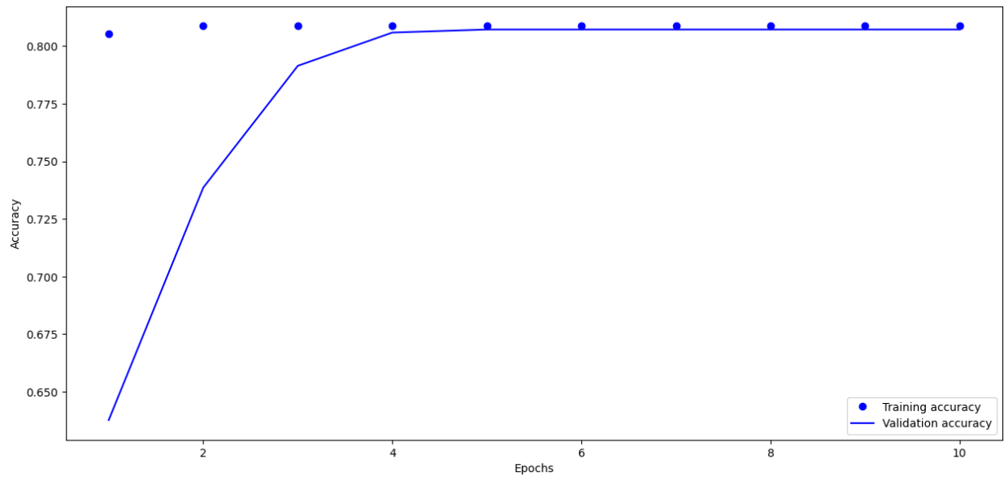

Lab 11

Lab 12

https://github.com/gokuljayan555/Neural-Networking/blob/main/LAB%20logbook.docx